**Fanka Shundovska**

**IntelliJ – JAVA Homework 3**

In IntelliJ:

1. Create variable of type int and assign value 10 to it.

* Print the variable value increased by 1.
* Or increase the value of the variable by 1 and after print the variable value.(use Increment Operator or Assignment Operator)

int a = 10;  
System.*out*.println(a + 1);  
a++;  
System.*out*.println(a);  
a = a + 1;  
System.*out*.println(a);

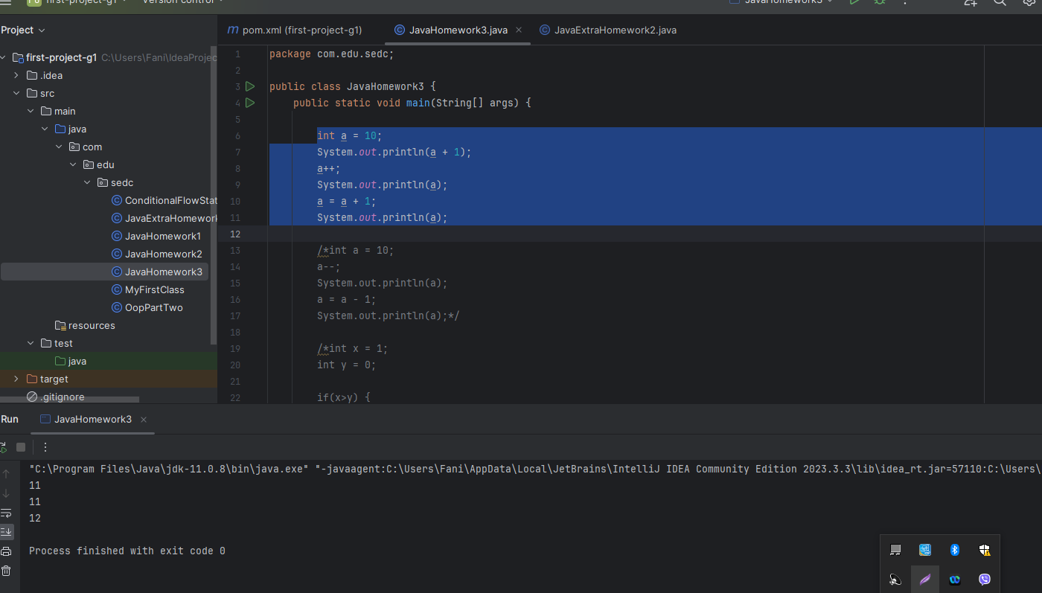

1. Create variable of type int and assign value 10 to it.

* Decrease the value of the variable by 1.(use Increment Operator or Assignment Operator).
* After print the variable value.

int a = 10;  
a--;  
System.*out*.println(a);  
a = a - 1;  
System.*out*.println(a);

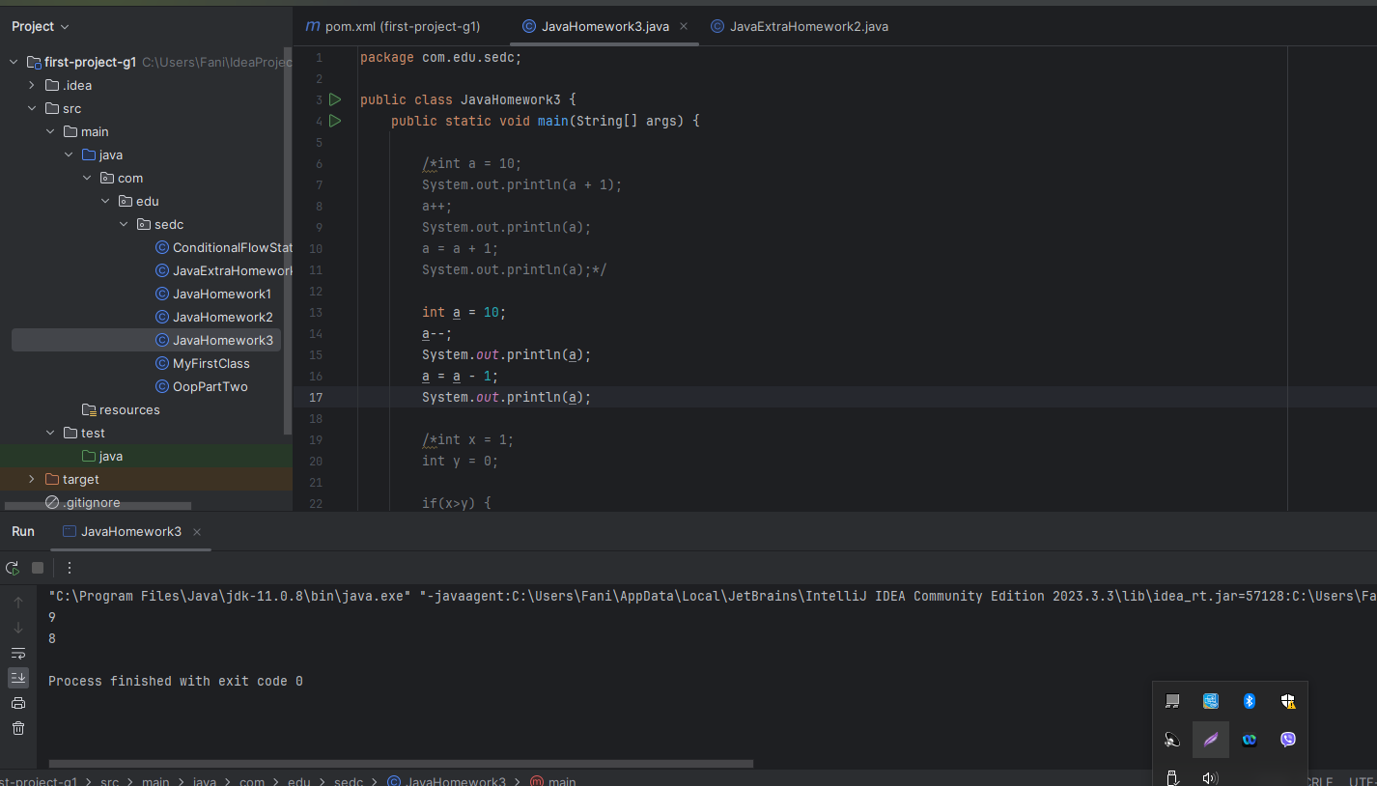

1. Write the java statement that assigns 1 to x if y is greater than 0.

int x = 1;  
int y = 0;  
  
if(x>y) {  
 System.*out*.println("x is greater than y");}

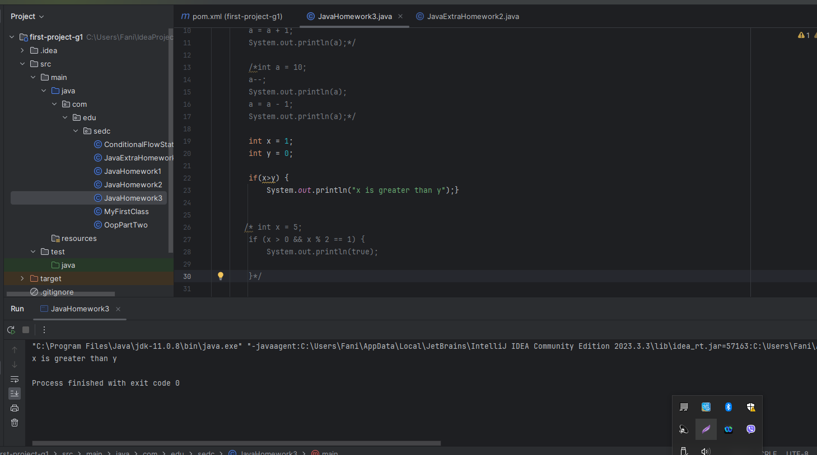

1. Write a java statement that prints true if x is an odd number (like 1,3,5 etc…) and positive.

int x = 5;  
 if (x > 0 && x % 2 == 1) {  
 System.*out*.println(true);  
 }

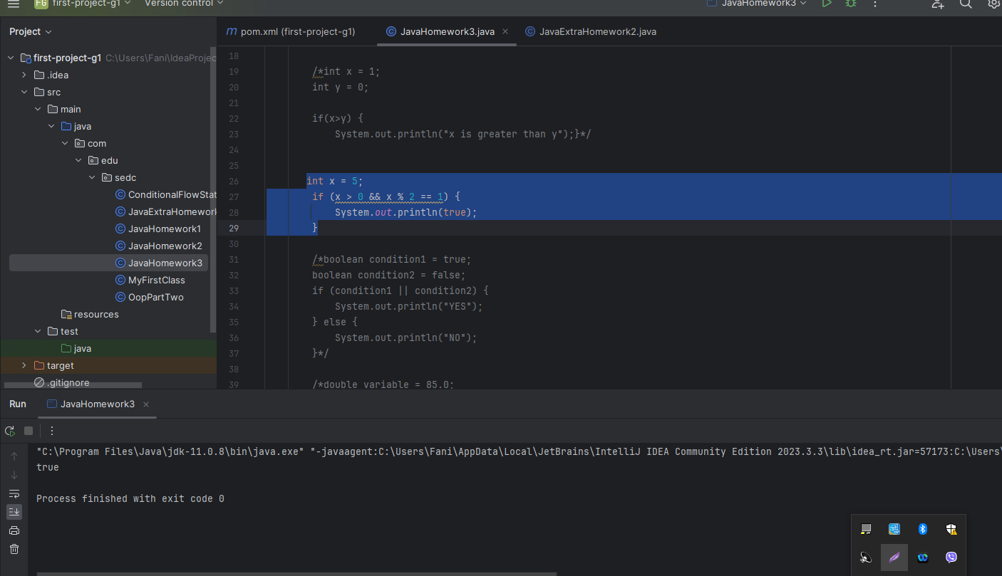

1. White conditional statement using OR logical operator to check if only one condition is true.

* If the condition is true - Print “ YES” or if the condition is not true print “NO”.

boolean condition1 = true;  
boolean condition2 = false;  
if (condition1 || condition2) {  
 System.*out*.println("YES");  
} else {  
 System.*out*.println("NO");  
}

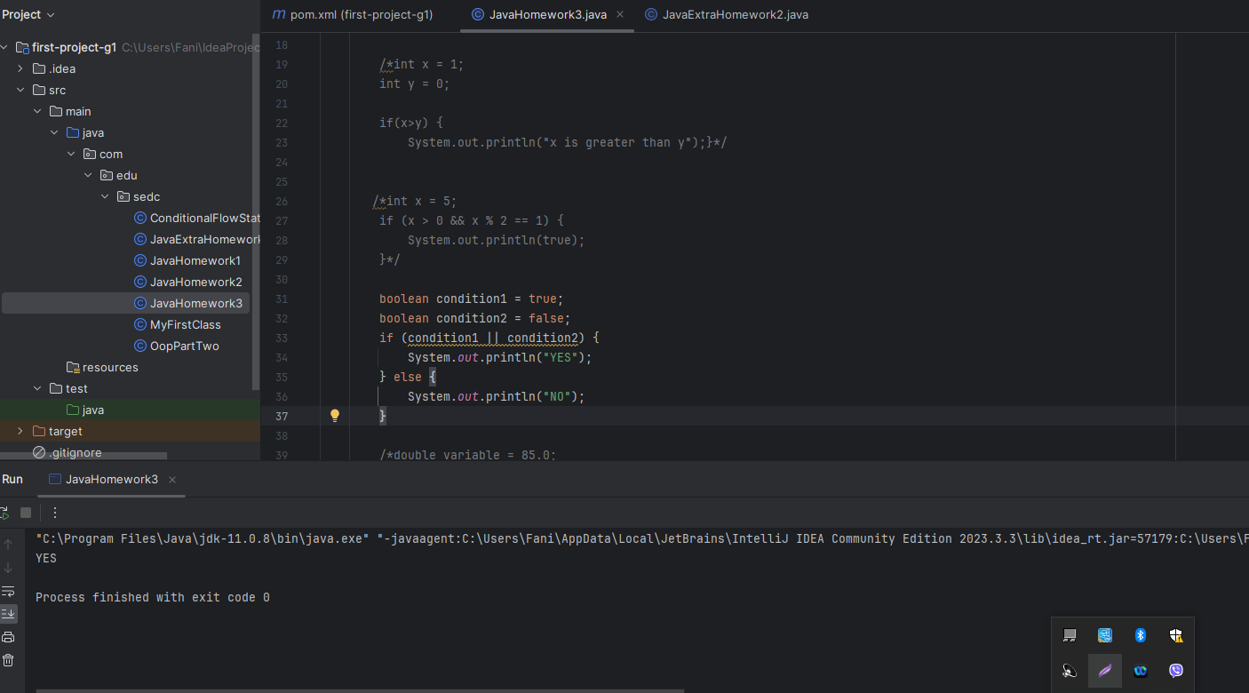

1. Declare variable of type double. Write the java statement which increases variable value by 5 marks if the value is between 80 and 90.

* If the value is less than 80 increase the value by 3 marks.
* If both statements are not true then set the printed output to be “The variable value isn’t changed”. Make the output of the first condition to be true and print the result.

double variable = 85.0;  
  
if (variable >= 80 && variable <= 90) {  
 variable += 5;  
 System.*out*.println("The variable value is " + variable);  
}  
else if (variable < 80) {  
 variable += 3;  
 System.*out*.println("The variable value is " + variable);  
}  
else {  
 System.*out*.println("The variable value isn't changed");  
}

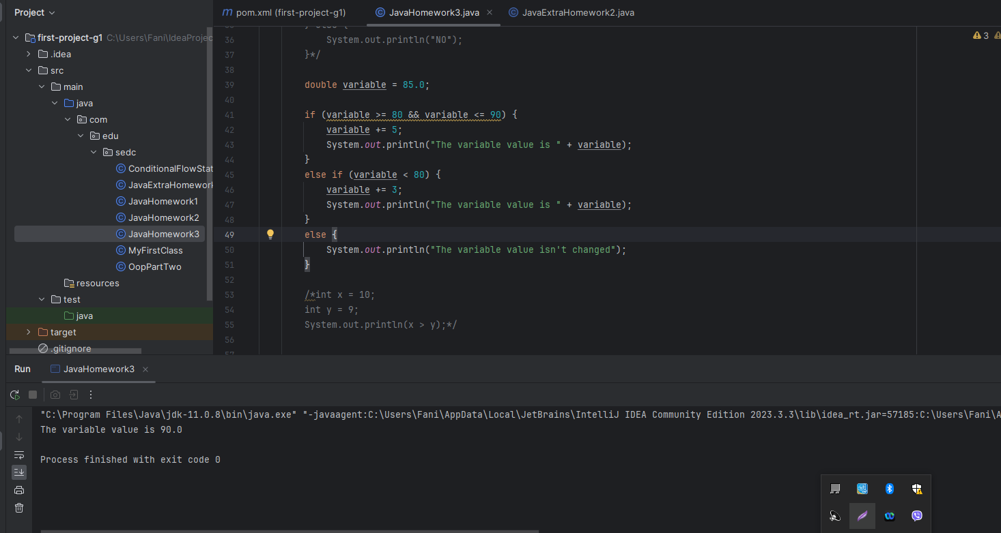

1. Fill in the missing parts to print the result true:

int x = 10;

int y = 9;

System.out.println( ___________ );

int x = 10;  
int y = 9;  
System.*out*.println(x > y);

